Marist Cricket Club

Established

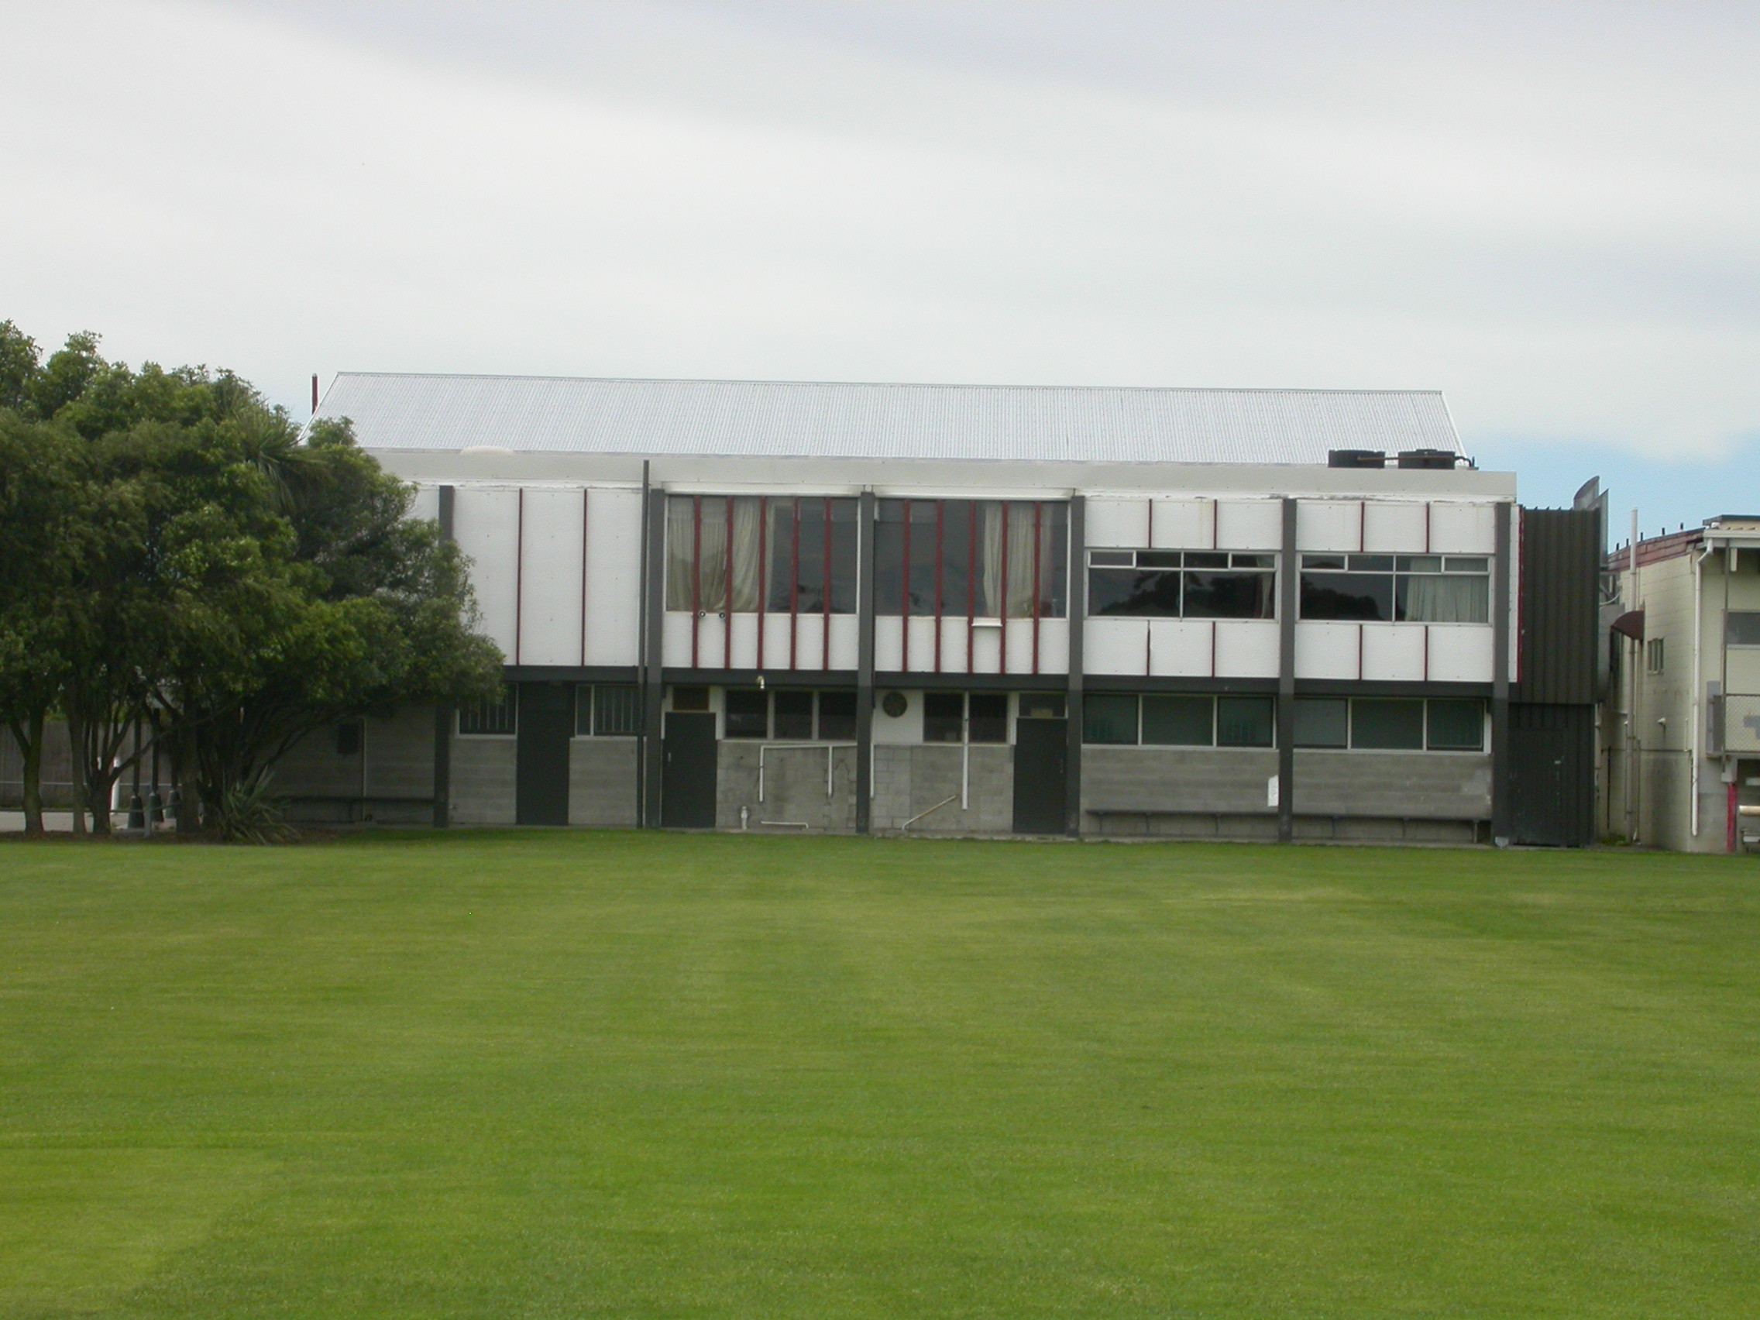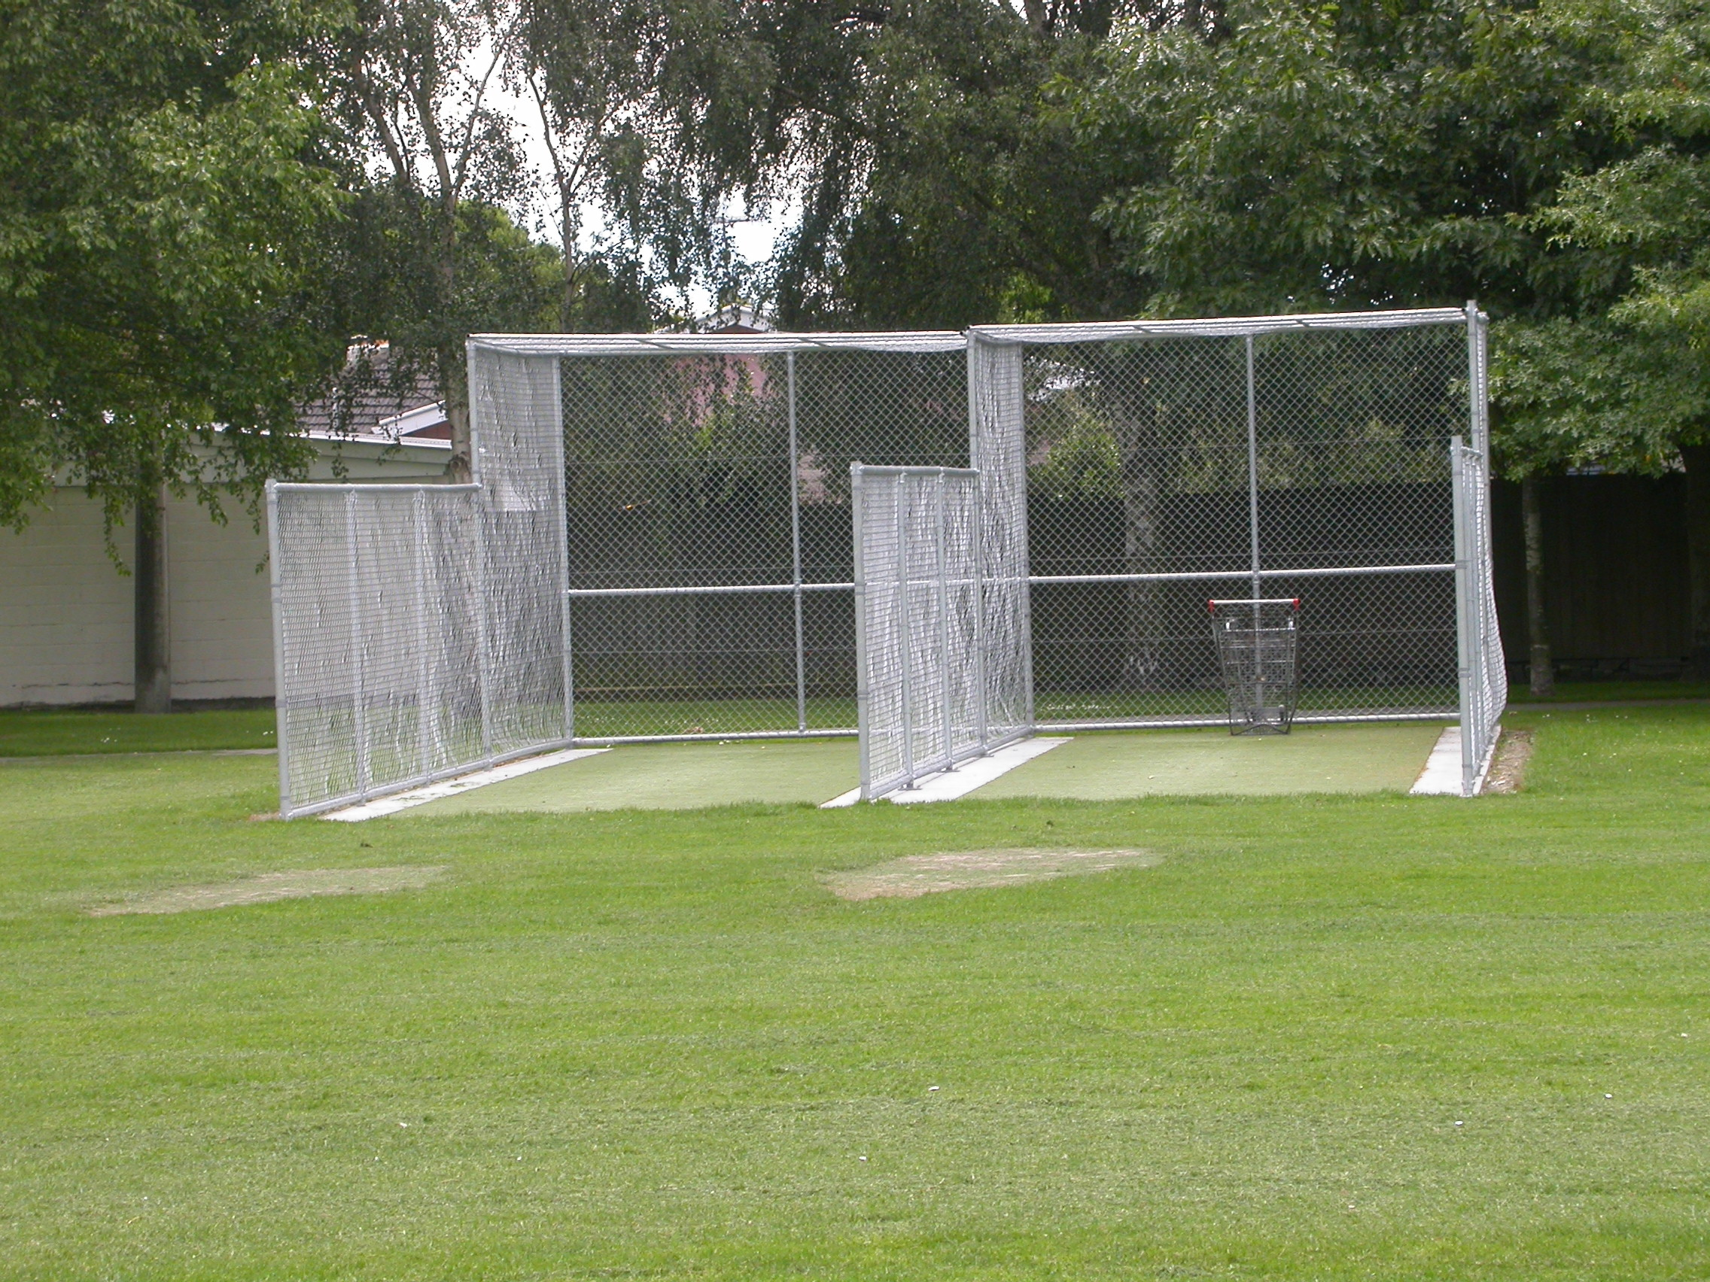

Home Ground Middleton Park
Match pitches 1 grass match pitches
Practice pitches Grass block Hagley Oval 2 artificial pitches Middleton Park

Entries 2001-02 6 men teams 3 junior teams
2002-03 5 men teams 1 junior team
2003-04 5 men teams
2004-05 5 men teams 2 junior teams
2005-06 5 men teams

Grade wins last 6 years
Men 2002-03 Seventh grade
2003-04 Sixth grade
2004-05 First combined grade Sixth grade
2005-06 Fifth grade

Subscriptions Adult $250
Student $150
Junior

Income 2004/05 Subscriptions $5,537
Gaming $73,611
Total $92,619
Expenditure Grounds $4,919
Gear $4,264
Total $64,915
Deficit $20,596
Accumulated Funds $32,861

